The Parks Medical Practice

Newsletter

PPG Blisworth – Roade – Hanslope – Grange Park Summer 2024

**Welcome to our Summer Newsletter**

Please read on for new team member updates, tips for summer, details of local support groups and coffee mornings, social prescribing team updates, flu vaccinations and much more…

**Are your contact details up-to-date?**

If you change your contact details such as your telephone number, please let our receptionists know ASAP so we can ensure your record is updated.

We are increasing the use of text messaging to reduce the amount of letters we send, saving NHS funds so it’s important we have the right contact details for you.

**Follow us on Facebook**

Please search for The Parks Medical Practice and follow us for regular updates.



We regularly post information such as site closures, telephone problems and much more on our Facebook page, along with helpful NHS and Wellbeing information.

**Have an appointment booked you can no longer attend?**

Please let us know as soon as possible as there may be someone who is in urgent need of an appointment.

During May & June, 501 patients Did Not Attend (DNA’d) their appointment.

That equates to 102 hours of clinical time with doctors, nurses and healthcare assistants wasted.

**Don’t be a DNA – please let us know**

**Surgeries**

**Park Slope Surgery Roade Surgery**

32 Stoke Road 16 London Road

Blisworth Roade

Northants Northants

NN7 3BT NN7 2NN

01604 878000 01604 863100

**Grange Park Surgery Hanslope Surgery**  
Wilks Way 1 Western Drive

Grange Park Hanslope

Northants Bucks

NN4 5DW MK19 7LA

01604 434747 01908 510230

*www.theparksmedicalpractice.co.uk*

**Surgery Opening Times**

**Monday to Friday 08:00-18:30**

**Blisworth, Roade, and Hanslope close at 12.30 – 14.30 each day**

**Grange Park open from 08.00-18:30**

**We are closed Saturday/Sunday and Bank Holidays**

.

**Practice Team Update**

We have welcomed the following new staff in the last few months:

**Hanslope Grange Park**

Dr Subrata Banerjea Dr Bijon Roy  
Dr Ahmad KusimoDr Tahira Waheed

Charlotte Luck and Claire Coulman nursing team Noleen De Castro – Receptionist   
Kirsty Fradi – Receptionist Laura Seymour - Receptionist

Leanne Hand - Site Manager

**Blisworth**

Natalie Bell - Receptionist

Our GP appointment structure is now 50:50 face-to-face appointments and telephone appointments. Of each type, half are pre-bookable, and half are same day bookable. Most of our Nurse appointments are now face-to-face.

The GPC (General Practitioners Committee) recently published an article on the national GP situation and stated the following:

*“GP workload and workforce GP practices across the country continue to experience significant and growing strain with declining GP numbers, rising demand, struggles to recruit and retain staff.*

*GP numbers are falling, with little increase in the overall number of GPs since 2015, and a significant decline in the number of GP partners over that time.*

Dashboard

**New Phone System**

Our new phone system has been installed for 2 months,   
we hope our patients have seen an improvement in being able to get through to the surgery. Like any new system there have been some teething problems but these have now been resolved.

**In the month on May we took 15,189 calls with the average queue time of 5m 24s**

**In the month of June we took 14,638 calls with the average queue time of 4m 54s**



**Additional Services available from The Parks Medical Practice**

As well as GP appointments, we provide a number of other medical appointments and ancillary services. Whilst your GP will refer you when needed, in many cases these services can be accessed directly via Reception or self-referral.

All of the staff concerned are trained in their specialist fields and if they cannot help directly, they will consult with your GP as necessary.

**The services are available to book/be referred to via Reception and include:**

**Phlebotomist** – taking blood samples that have been requested by Doctors only

**Health Care Assistants (HCA)** – blood samples, blood pressure, height and weight checks, ECGs, ear syringing, simple dressings, NHS Health Checks

**First Contact Physiotherapist** – new onset muscoloskeletal pain, bad knee/hip etc. including sprains, bad backs etc.

Primary Care (GP Practices) ***cannot*** help with: suspected broken bones, severe bleeding, seizures, major injuries that need stitches, head injury with loss of consiousness, severe chest pain, respiratory distress. For these issues you should go to your nearest A&E department or call 999.

**General Practitioners (GPs)** – supporting the rest of the clincial team. Management of complex chronic care including mental health, pain management, cancer care and palliative care. Assessment, safety netting and referral to secondary care for conditions requiring specialist input. Managing treatment plans as advised by secondary care

**Age Well Team** – supporting patients aged 65+ to stay happy and healthy. Can refer to wider community teams to help with equipment/mobility adis and social/financial worries. Also support carers and dementia patients. You can self-refer by emailing [pml.parkwoodagewell@nhs.net](mailto:pml.parkwoodagewell@nhs.net)

**Social Prescribers** – supporting patients with non-clinical problems, low level anxiety and depression, loneliness, bereavement, financial and housing worries. You can self-refer by asking at Reception to be linked to a Social Presriber, or whilst you are in with a clincian

**Clinical Pharmacists** – medication queries and reviews. Medicine optimisation and deprescribing where appropriate

**Practice Nurse** – smears, swabs, complex wound care, compression bandaging, asthma checks, immunisations, chronic disease reviews (diabetes and COPD), hypertension, health promotion and advice

**Nurse Practitioner, Paramedic, Advanced Nurse Practitioner (ANP)** – minor illnesses – chest infections, cough, sore throat, skin infections, wounds, minor injuries. Some have additional skills such as ear microsuction

**Northamptonshire Carers’ Monthly Drop-In**

**at The Blisworth Baptist Chapel Coffee Morning**

Northamptonshire Carers is a registered charity supporting unpaid Carers around the county.

As part of this support, and at the invite of the Parks Surgery PPG, a member of the Northamptonshire Carers staff attends the **Coffee Morning** on the **3rd Tuesday of each month** at **The Baptist Chapel in Blisworth**. They provide information and advice which includes:



* **A listening ear and emotional support**
* **Signposting and referral to other organisations**
* **Access to Carers’ assessments/personal budgets**
* **Peer support**
* **Access to Carers’ sitting services**
* **Carers’ Support Line**

Other services provided by Northamptonshire Carers in the area include:

* **Carers’ Support Group in Towcester**
* **Carers’ Lunch Club at Greens Norton**

See below for further information on these services.

If you would like to know more about any of these services or to discuss your own caring situation, please drop in and see them at the Coffee Morning or contact them on:

Carers Support Line: **01933 677 907 option 2** – open Monday – Friday 9am – 4pm

Email: **carers@northamptonshire-carers.org**

Website: **www.northamptonshire-carers.org**

**For further events please look at Northamptonshire Carers website under events**







**Blisworth Coffee Morning**

**Held at**

**Blisworth Baptist Church**

**Chapel Lane**

**Blisworth**

**NN7 3BU**

**3rd Tuesday of the month**

**10am – 1145am**

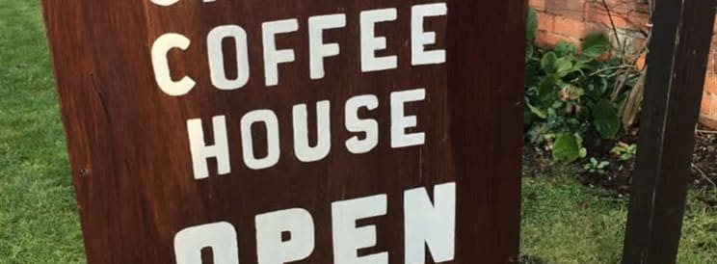

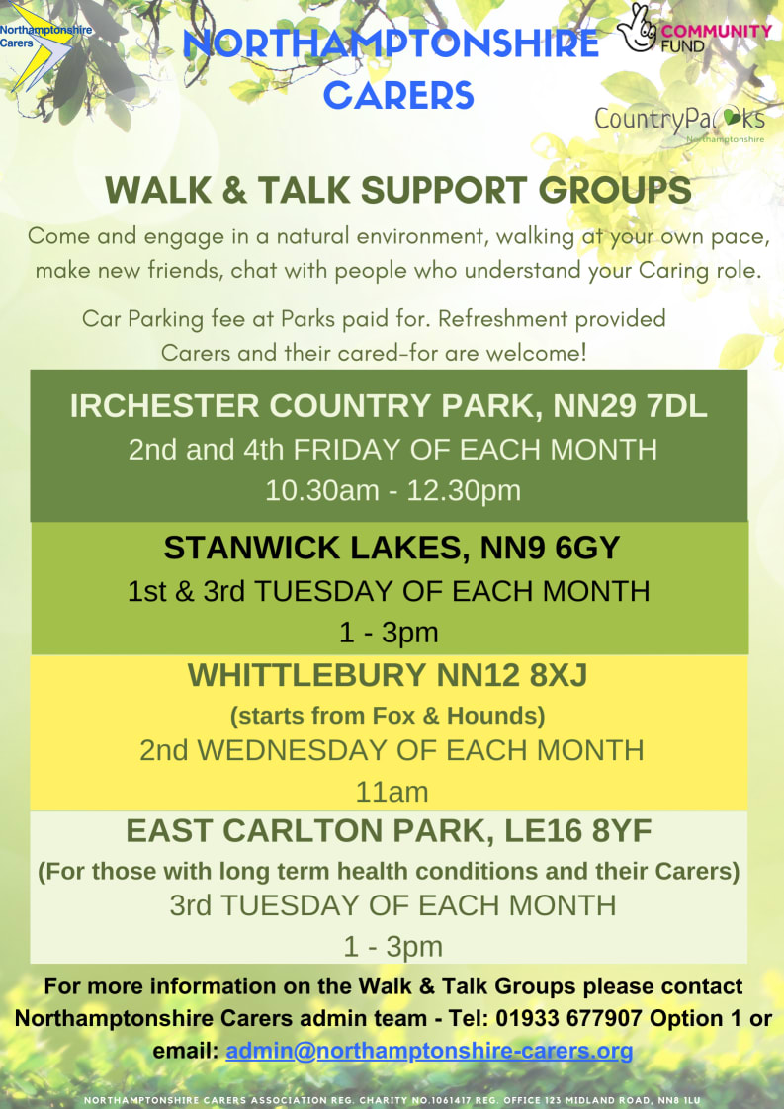

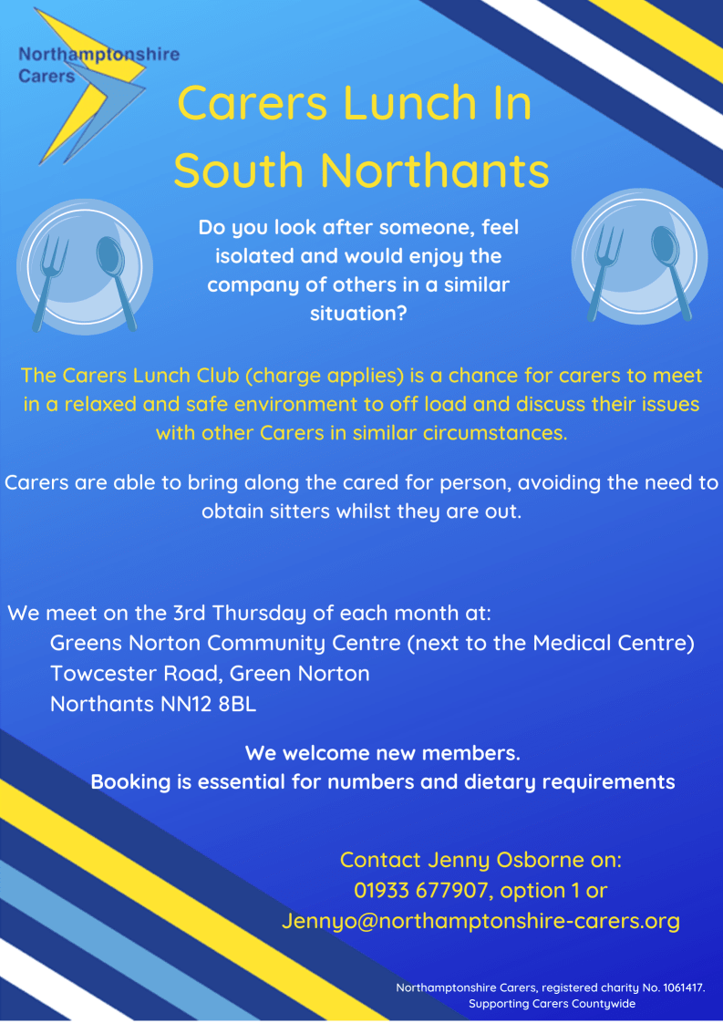



Hanslope and District Cancer Wellbeing and Support Group

Practical help and support groups

Our group meets on the third Monday of each month at 8pm for 2 hours April to September at St James Church, Hanslope MK19 7LT in the coffee area and from October to March at 12 Weavers End, Hanslope MK19 7PA. We aim to offer emotional support and information to those in our area affected by cancer (and their families). It is an open and accessible to all irrespective of faith, religion, colour or creed. The group offers mutual support, collects and disseminates information on all matters relating to cancer and acts as a signpost to other relevant agencies. Strict confidentiality is maintained at all times.

Group supports Adults, Carers, Patients, Relatives, Young adults affected by cancer, Young adults with cancer, Parents of Children or Young Adults with cancer, Men, Women, Disabled Access

We offer:

* Cancer information materials
* Information
* Opening times:

Please contact group for further details

Interested in joining us?

Just come along to our next meeting, or get in touch with us on the details below.

Find out more:

* John Sorrell on 07889181158 / 01908 510747 (9am-7pm only)
* [john.e.sorrell@gmail.com](mailto:john.e.sorrell@gmail.com)

**Tips for Summer**

**Sun protection**

Sunburn increases your risk of developing skin cancer. This can happen in the UK as well as abroad.

* Spend time in the shade between 11am and 3pm – this is when the sun is at its strongest in the UK from March to October
* Cover up with suitable clothing and sunglasses.
* Use at least factor 30 sunscreen, and ensure you apply enough – adults should aim to apply around 2 teaspoons of sunscreen for your head, arms and neck, and around 2 tablespoons if you’re covering your entire body while wearing a swimming costume.
* Take extra care with children.

If you do get sunburnt:

* Get out of the sun as soon as possible and cool your skin with a cool shower, bath or damp towel
* Apply after sun cream or spray, such as aloe vera
* Drink plenty of water to cool down and prevent dehydration

For more information, please visit [www.nhs.uk/live-well/seasonal-health/sunscreen-and-sun-safety/](http://www.nhs.uk/live-well/seasonal-health/sunscreen-and-sun-safety/)

**Hay fever**

Hay fever is usually worse between late March and September when the pollen count is at its highest.

Some of the symptoms of hay fever include:

* Sneezing and coughing
* A runny or blocked nose
* Itchy, red or watery eyes
* Itchy throat, mouth, nose and ears

If you have asthma you may also experience a tight feeling in your chest, be short of breath, wheeze, and cough.

How to ease your symptoms of hay fever:

* Put Vaseline around your nostrils to trap pollen
* Wear wrap-around sunglasses to stop pollen getting into your eyes.
* Shower and change your clothes after you’ve been outside to wash pollen off
* Keep windows and doors shut as much as possible.

Speak to your local pharmacy who can give advice and suggest the best treatments.

For more information, please visit [www.nhs.uk/conditions/hay-fever/](http://www.nhs.uk/conditions/hay-fever/)

**Have you tried eConsult?**



eConsult enables GP practices to offer online consultations to their patients. This allows patients to submit their symptoms or requests to their GP electronically, and offers around the clock NHS self-help information, signposting to services, and a symptom checker.

To use eConsult, visit our practice website homepage where you will see an eConsult link, this will then take you to a webpage where you can find self-help information and a form for you for you to fill in at your own pace and submit to the practice if you need their help/advice.

The practice reviews every eConsult and decides upon the right care for each patient. This may be a one-way message with advice or information, a telephone or video consultation or a face-to-face appointment. We can also determine whether you are best suited to speak to/see a doctor, nurse or pharmacist.

Visit our practice website at [*https://www.theparksmedicalpractice.co.uk*](https://www.theparksmedicalpractice.co.uk)

**Important things to note before using eConsult:** 

* eConsults are reviewed during our working hours. If you need urgent advice outside of our working hours, please contact 111.
* eConsults should ***not*** be used in an emergency – call 999 or go to your nearest A&E Department.

**Would you like to join the PPG?**

Title: Would you like to join the Patient Participation Group (PPG)?

Each of the 4 GP surgeries has 2 members as core representatives, who meet 6 to 8 times a year together with the Practice Manager and other medical staff to discuss ideas and ways to improve the service.

If you are interested and would like to find out more information, please contact the Practice Manager, Angela Wing, email [Angela.wing5@nhs.net](mailto:Angela.wing5@nhs.net) who will pass on your details to a PPG member to discuss with the group further.